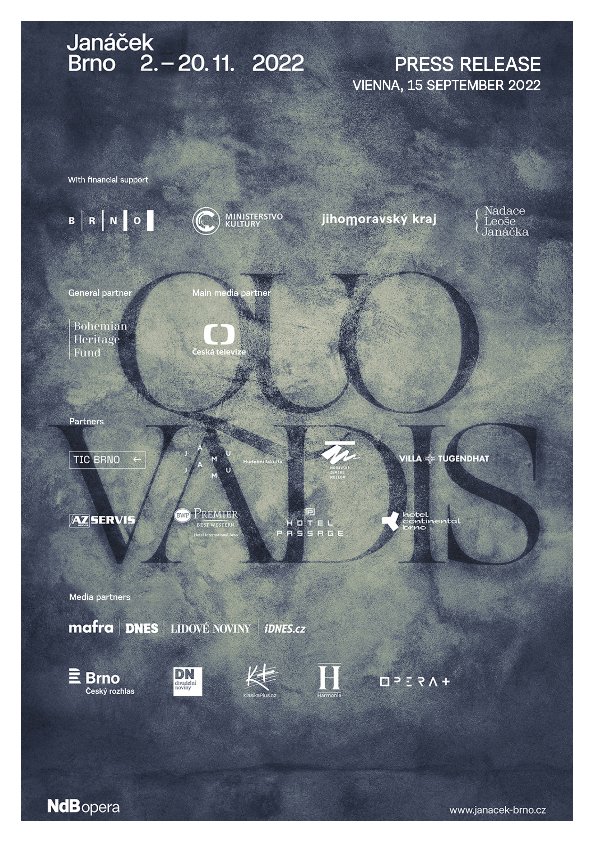

Top Czech conductors at the Janáček Brno 2022 festival
Press release from 15th September 2022

Brno is all set to show why its reputation as a world-class cultural capital is justified for the eighth time, thanks to the Janáček Brno international opera and music festival. From 2nd to 20th November 2022, the city will be filled with the works of Leoš Janáček and other artists who inspired him on his creative journey, or who were inspired by him. Led by the conductors Jakub Hrůša, Tomáš Hanus, Tomáš Netopil and Marko Ivanović, and featuring famous Czech and foreign ensembles, the festival will feature the theme “Quo Vadis”, referring to Janáček´s favourite spiritual cantata by Feliks Nowowiejski.
The programme of the festival, which was awarded the prestigious International Opera Award for the best festival of 2018, can be thought of as being divided into two main components – a theatre part and a concert part, which together offer a very diverse and attractive selection of music and drama.
The theatrical part of the programme is dominated by renowned foreign ensembles: the Swiss Grand Théâtre de Genève with their production of Katya Kabanova conducted by Tomáš Netopil and directed by Tatjana Gürbaca, and the Welsh National Opera with the Makropulos Case, with Olivia Fuchs as director and Tomáš Hanus as music director. “For me personally, one of the highlights of the festival will be the American soprano Corinne Winters, who will portray Katya Kabanova in the Geneva production. Corinne excelled in this year´s Salzburger Festspiele, where Janáček´s opera became a real high point of the programme,” says Jiří Heřman, the head of the Janáček Opera, National Theatre Brno, by way of an invitation, “and also the young tenor Nicky Spence, who will be attending with the Welsh National Opera, is going to be great. He’s a regular guest at London´s Covent Garden and New York´s MET. He will also perform in The Diary of One Who Disappeared with the excellent pianist Julio Drake and the Brno Opera soloist Václava Krejčí Housková. Their joint CD won, for example, the BBC Music Magazine Awards 2020 and the Gramophone Classical Music Awards 2020. This is an amazing achievement,” he adds. The Welsh ensemble will also feature baritone David Stout as Baron Prus and Spanish soprano Angeles Blancas Gulin in the role of Emilia Marty.
Opera productions will also be offered by Czech ensembles – as is now a tradition, the ceremonial opening of the festival will feature a new production by National Theatre Brno’s Janáček Opera, Glagolitic Mass / From the House of the Dead. It will be the first performance of the theatre version of Glagolitic Mass, with Jakub Hrůša as conductor and Jiří Heřman as director. This production will be broadcast live by Opera Vision on 6th November, in cooperation with Czech Television, via live streaming. The Opera of the National Theatre and the State Opera (Prague) will also offer Katya Kabanova and Schulhoff´s Flames, both directed by Calixto Bieito and conducted by Jaroslav Kyzlink (Katya Kabanova) and Jiří Rožeň (Flames).
As regards the concert side of the programme, well-known foreign orchestral bodies will be there, such as Switzerland’s Orchestre de la Suisse Romande, who have made over 100 recordings for DECCA – and famous British violinist Viktoria Mullova will be performing with them under the baton of conductor Tomáš Netopil. The Welsh National Opera with its chief conductor Tomáš Hanus will perform work by not only the British composer Benjamin Britten and Leoš Janáček, but also Dvořák´s Biblical Songs, performed by the Czech singer Adam Plachetka. The festival will also offer a unique opportunity to hear a rarely performed work: Sommer´s Vocal Symphony, featuring the Czech Radio Symphony Orchestra, Prague Philharmonic Choir, Ondřej Brousek and Markéta Cukrová, and conducted by Marko Ivanović. It promises to be a great artistic experience, as does the oratorio Quo Vadis by the Polish composer F. Nowowiejski, which will appear in an extraordinary staging by the American conductor John Fiore with soloists Tomasz Konieczny and Csilla Boross.
There will also be chamber concerts with well-known performers such as Josef Špaček, Iva Bittová, Miroslav Sekera, Ivo Kahánek, Tomáš Jamník and Martin Kasík, as well as chamber ensembles Pavel Haas Quartet, Zemlinsky Quartet and Brno Contemporary Orchestra. As with every festival, young people from both the Brno Conservatory and the Music Faculty of the Janáček Academy of Music and Performing Arts, whose students have prepared two operatic world premieres, will also be given ample space.
The director of National Theatre Brno, Martin Glaser, says about the festival: “I think that the location where the festival takes place is also a great asset – Brno, where Leoš Janáček lived and created, is a cultural and social centre that has seen mention in the New York Times and The Guardian. The varied music scene, of which our theatre is a part, has caused Brno, together with the legacy of Leoš Janáček, to be included on the UNESCO list of cities of music.” The Janáček Brno festival also offers many accompanying events throughout city – exhibitions, the Open House non-traditional tour behind the scenes at the Janáček Theatre, and the opportunity to take a guided tour of the city via the Janáček Trail and learn a lot of interesting facts about the master.
Visitors can find up-to-date information on the festival and an online ticket purchasing service at www.janacek-brno.cz. A festival pass is available for festival visitors, thanks to which they will obtain a 25% discount when purchasing tickets for three or more performances and a 30% discount when purchasing five or more. Some concerts are already sold out right now.
The festival takes place with financial support from the statutory city of Brno, the Ministry of Culture of the Czech Republic, the Leoš Janáček Foundation and the South Moravian Region. The general partner of the festival is the Bohemian Heritage Fund. The main media partner of the festival is Czech Television.

JANÁČEK BRNO 2022
8th international opera and music festival
QUO VADIS

Contact:
Alena Navrátilová Ochrymčuková
PR and marketing of the Janáček Opera, National Theatre Brno
email: ochrymcukova@ndbrno.cz
telephone: +420 702 267 991

Link to a video presentation of the festival: Janáček Brno 2022
Link to festival photos: https://www.flickr.com/photos/196440348@N02/albums/with/72177720301906695
Web link: https://janacek-brno.com
Link to accompanying programme: https://www.leosjanacek.eu/en/

